**Assignment 7**

Q1. Create an HTML page with the following elements. On click of the button, the clock should start in the text box and keep on updating with the current system time.

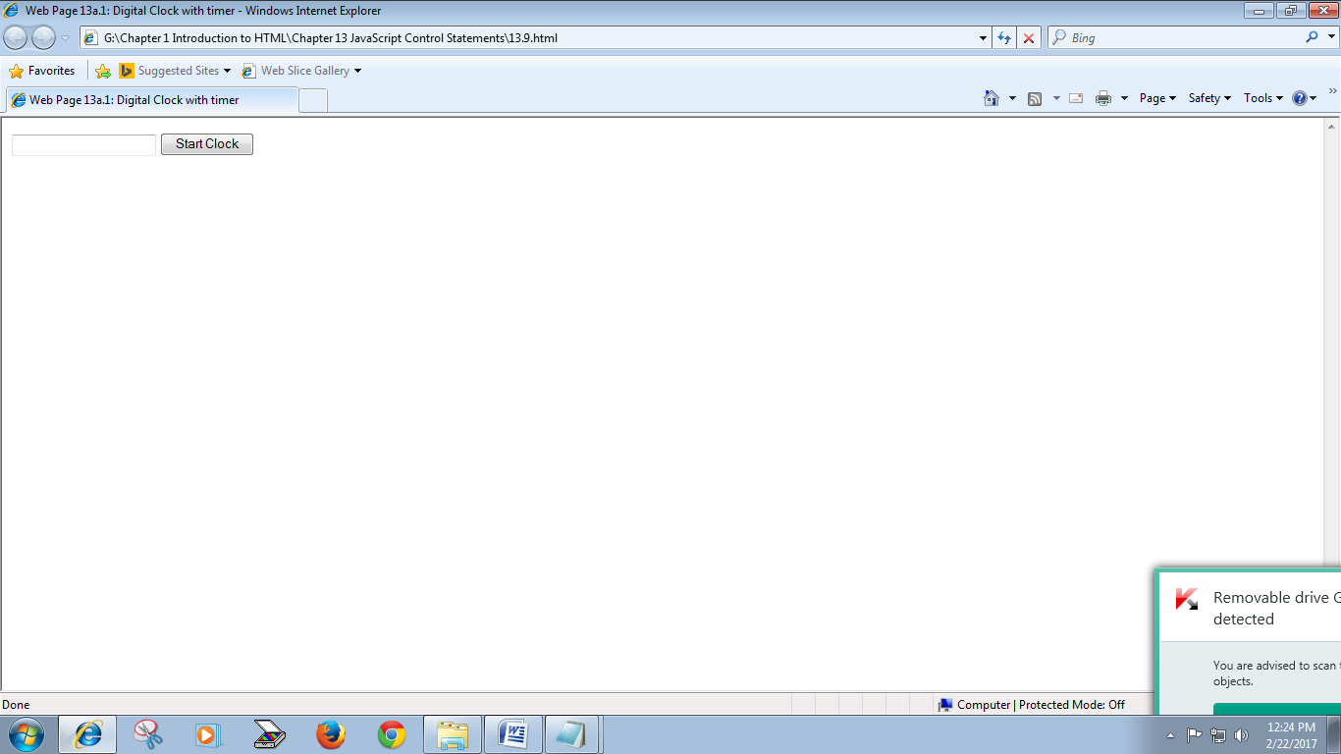

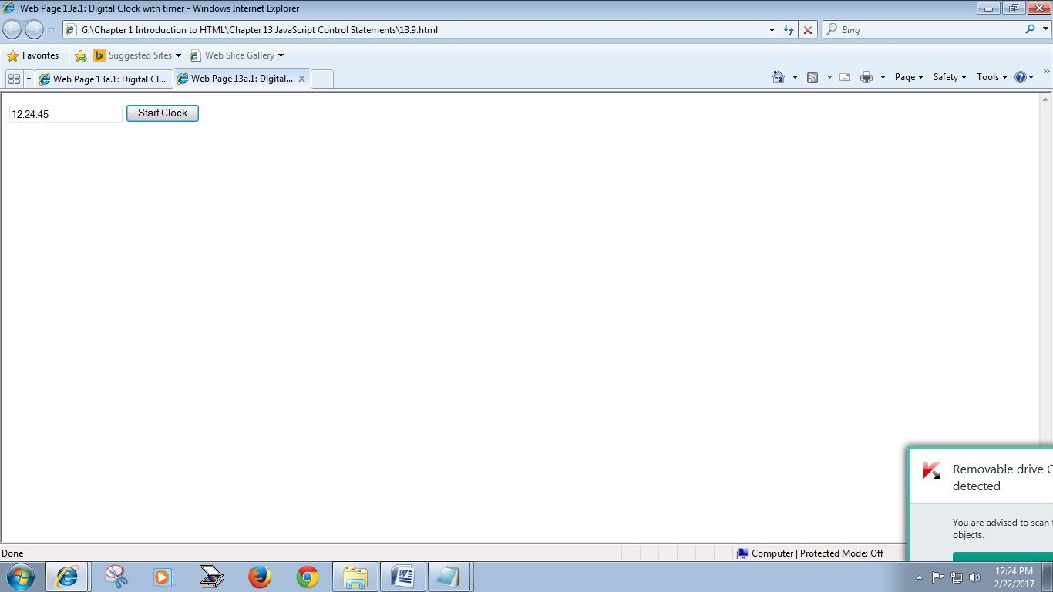

Q2. Create the following web page using FOR loop with break and continue.

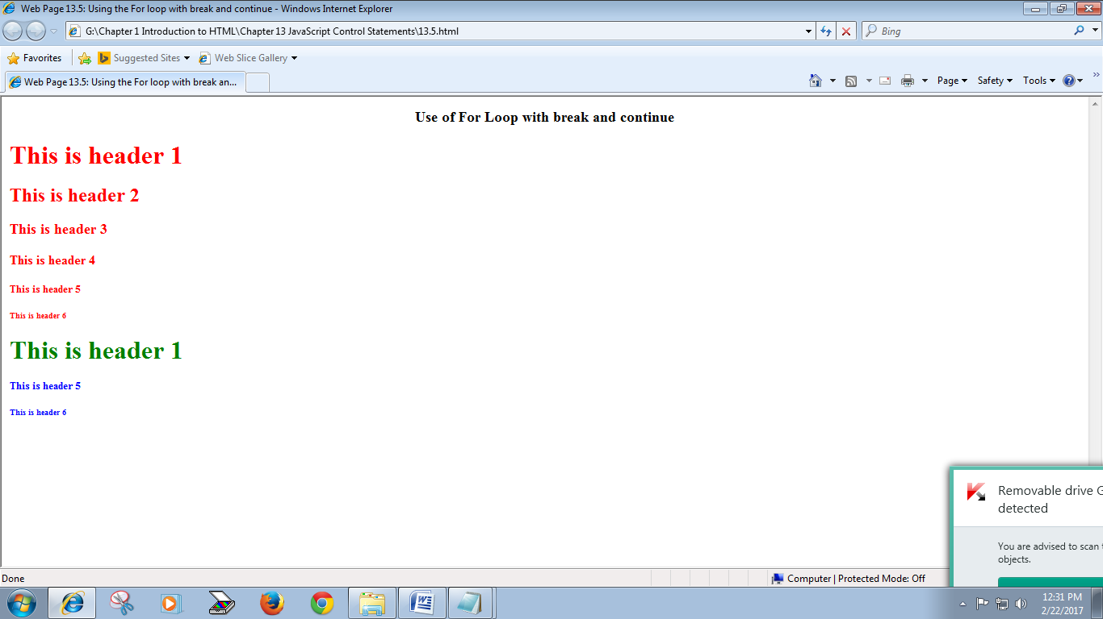

Q3. Write a java script program that should determine the current time and display the message “Welcome Shoppers !!!” if the time is 9-5 p.m. else ““Sorry, we are closed at this time” message should be displayed.

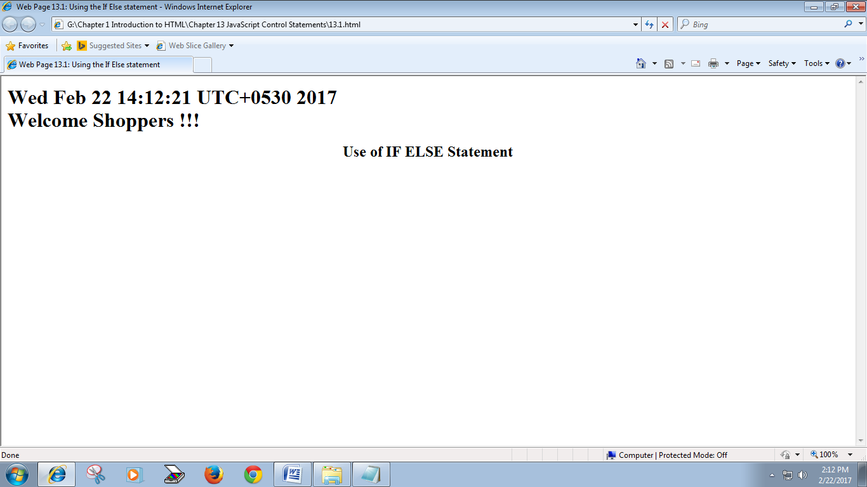

Q4. Write a JavaScript program that should get the current system day and display the following message:

If the day is Friday, the message “Finally Friday !!! Exhausted ...” should be displayed, if the day is Saturday, “Super Saturday !!! Enjoying fully ...” should be displayed. For Sunday, “Sleepy Sunday !!! Relaxing ...” should be displayed and “I'm prepared for any work during working days !!!” for any other working day should be displayed. Eg.

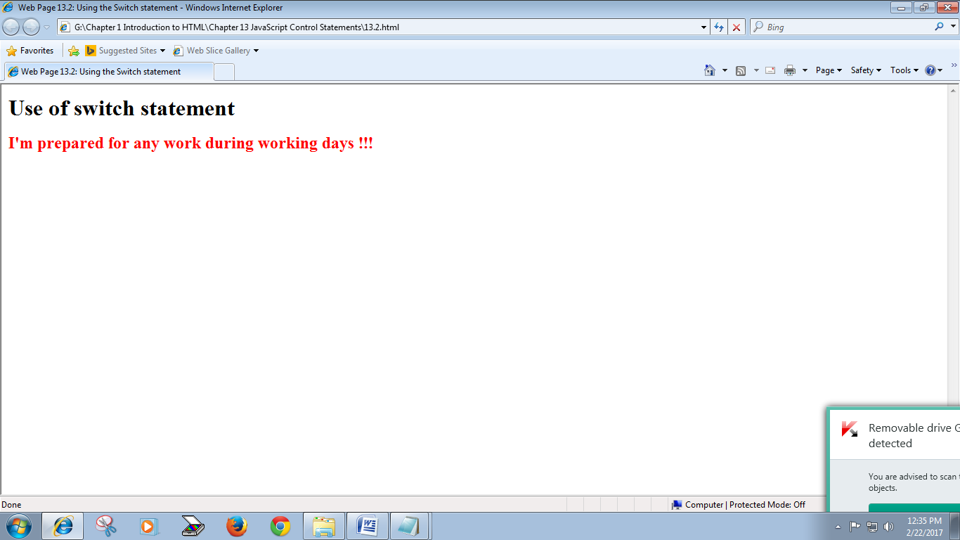

Q5. Write a java script program that should create two arrays a1=["Ram", "Sham", "Sita", "Mohan"] and a2=["Raman", "Neha"] and print the following using array functions:

**Printing the items of both the arrays:**

**Array 1:**

Ram

Sham

Sita

Mohan

**Array 2:**

Raman

Neha

**Length of Array 1 =** 4

**Length of Array 2 =** 3

**Two arrays after concatenation:**

Ram

Sham

Sita

Mohan

Raman

Neha

**Extracting the elements 2-4 from array 1 in a new array:**

Sham

Sita

Mohan

**Reversing the elements of the 1st array:**

Mohan

Sita

Sham

Ram

**Sorting the elements of the 1st array:**

Mohan

Ram

Sham

Sita

**Joining elements of array 1 using "*":**

Ram*Sham*Sita*Mohan

**Changing the 1st two elements of array 1:**

Sunaina

Sonia

Sham

Sita

**Element removed using Shift:**

Sunaina

**Inserting "Swati" at the top:**

Swati

Sonia

Sham

Sita

**Inserting "Raj" at the end:**

Swati

Sonia

Sham

Sita

Raj

Q6. Write a java script program to accept a number from the user using prompt dialog box on the click of a button. If the number is > 100, the user should be alerted to enter the number <= 100. On entering the correct number, the webpage should print the factorial of the number using recursion.

Q7. Create a web page to display the basic calculator (using forms & javascript) and prompt the user if textbox is empty.

Q8. Write a JavaScript program to rotate the string 'Web Programming' in right direction by periodically removing one letter from the end of the string and attaching it to the front

Q9. Write a JavaScript code to validate the facebook form that was developed in Assignment 4 (Q5).